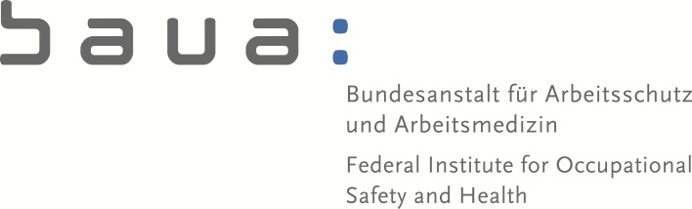
Bundesstelle für Chemikalien
Email:
chemg@baua.bund.de

Contact:
Andreas Fleischer
Sabine Darschnik

49 (0) 231/9071 – 2535
RN: 5.0-720 34/01/2018.0069

Dortmund, 16 July 2018
Federal Office for Chemicals
Friedrich-Henkel-Weg 1-25
D-44149 Dortmund/Germany

27th Meeting of Competent Authorities for REACH and CLP – follow-up CLP session

Agenda point 4 “Update of ATPs to CLP” – Classification of Cobalt

During CARACAL 25 the Commission indicated that there are substantial objections concerning the SCL for cobalt as a result of the evaluation as a high potency carcinogen. The method to derive the carcinogenic potency of chemicals is described in the Guidance on the application of the CLP Criteria and based on the T25 concept. This T25 concept was however not developed for inhalation tests on in-organic substances. On that background the Commission proposed to include the modified classification of Cobalt in the 14th ATP but wait for improvement of the potency evaluation before the SCL for Cobalt is derived and included.
The German CA supports an update of the methodology. However, we assume that a sound re-evaluation of the T25 method concerning inhalation of in-organic material will not be a project of a few months and could eventually take years. We foresee that appropriate data need to be gathered and evaluated and suggest that also the toxicological expertise from RAC is included in the evaluation process of the new method. Therefore the procedure and scheduling to implement the SCL needs to be clarified.

